Duration  60 minutes | Theme  Outdoor Learning | Subject focus  Literacy | Age group  Year 2
Resources required
- Access to a natural space
- Double sided sticky tape (optional)
- Superlative cards (see resources)
- Materials for threading (optional)
Adult Support
- Support the children to develop rules applicable to comparative and superlative adjectives
- Display associated language and examples to which the children can refer
- Ensure the children are familiar with any rules for collecting natural objects, for example, prickly and stinging plants, not picking flowers and leaves
Follow up activities
- Create a classroom display or perhaps a gallery in the school grounds for all to enjoy

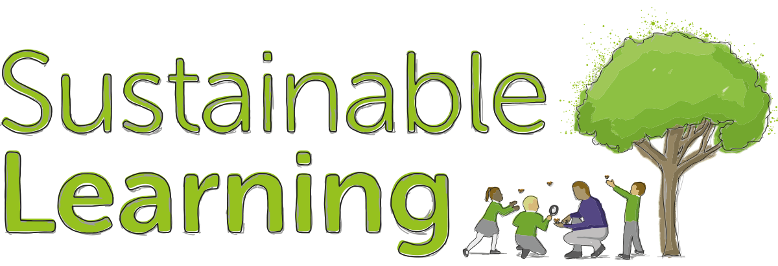

Lesson plan: Natural Comparisons
Learning objective: Use the suffixes ‘er’ and ‘est’ to show comparative and superlative adjectives
Learning outcomes (differentiated)
Keywords
superlative
adjective
suffix
syllable
superiority
comparative

MUST: Use the concept of sequence to compare a variety of items and describe using own terminology
SHOULD: Be able to describe how superlatives work and give a definition
COULD: Compose their own comparative and superlative adjectives to challenge others
Starter
This part of the lesson could be completed indoors but will probably be a lot more fun in a bigger, outdoor space where it can be a lot more physical!
Arrange the class into teams (approximately 6 people in a team) and explain the rules of the game, which are outlined below. Then play the game.
Rules of the game
The teacher will hold up a card with a word on it (see resources), for example, ‘tallest.’ Each team must then confer and agree one representative they will ask to step forward. Once each team has made a selection the teacher and class will agree which of the representatives is in fact the ‘tallest’. The ‘tallest’ individual scores two points on behalf of their team. The person in second place (who is ‘taller’ than the rest but not ‘tallest’) scores one point on behalf of their team. Points can be allocated by handing out the relevant cards won by each team.
Main activity
Once completed, look as a class at the word cards used. What do the children notice about the word structure? Together try to establish a rule which applies to the comparative and then to the superlative. Record it in a way that will be memorable for the class and display.
Generally:
- If an adjective has two syllables you then add the -er suffix to create a comparative. To create a superlative you add -est (but take care to note about spelling patterns depending on the word ending).
- If an adjective has three or more syllables then use the word ‘more’ to create a comparative or ‘most’ for a superlative.
Note however that there are inevitably exceptions.
If not already there, move into the outdoor space. Explain to the children that the they can now utilise their new-found knowledge of comparatives and superlatives using natural materials.

Lay out each set of cards in a linear way (see resource but note they may need adapting depending on the season). Give the children an opportunity to consider each category before giving them time to collect an item for each criteria (10-15 minutes dependant on the space and abundance of useable natural materials available). For example, one set of cards may read ‘green leaf,’ ‘greener leaf’ and ’greenest leaf.’ Each group must then go and collect a green leaf which they believe may be the greenest before gathering other items in the same way for every other criteria.
Once the time is up, call the class together and in turn invite them to place an item in a line for each criteria, for example from ‘green’ to ‘greenest’. They must position them appropriately by comparing their item to those already placed (there may be some lovely discussion at this point because, often it will be subjective, but this will only strengthen their understanding of the key language as the debate commences!).
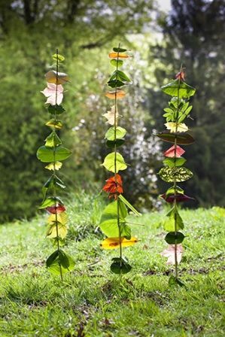
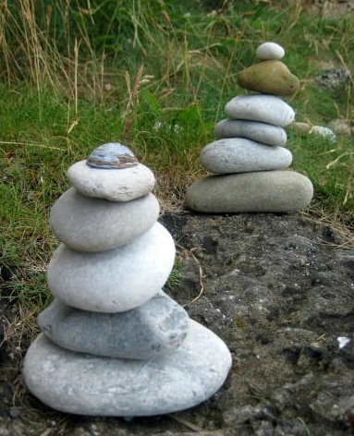

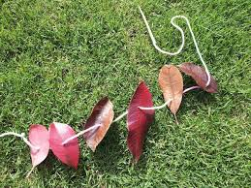

Plenary
Once the challenge is complete a classroom display can easily be created by photographing the collections, or, better still, creating some natural art by threading items or placing them on a strip of double sided sticky tape. You could even build natural cairns (see above). The children can then label them accordingly.
Extension tasks
- Invite children to come up with their own criteria with which they can challenge another team.
Reflective Notes

Curriculum links
English Year 2

- Read words containing common suffixes
- Add suffixes to spell longer words

English Year 3/4

- Apply their growing knowledge of root words, prefixes and suffixes (etymology and
morphology) as listed in English Appendix 1, both to read aloud and to understand
the meaning of new words they meet
- Use further prefixes and suffixes and understand how to add them (English
Appendix 1)

